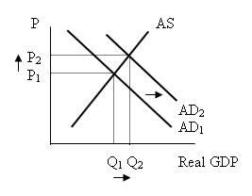

- Describe a specific event that could have caused the shift shown in the graph above.

2. When aggregate demand (AD) increases or shifts to the right, the equilibrium price

level ____________________, equilibrium output ____________________, and
increases/decreases increases/decreases

the rate of unemployment ____________________, assuming aggregate supply
increases/decreases

is upward sloping, as shown in the graph for question 1.

